📌 Overview
This Power BI dashboard analyses social media usage patterns, user demographics, platform preferences, and engagement behaviour. It helps identify trends in how users interact with different social media platforms.

🛠️ Tool Used
- Power BI
- Power Query
- DAX
- Data Modeling

📁 Dataset
You can view the dataset used in this project here:
🔗https://www.kaggle.com/datasets/hamnamunir/social-media-user-behavior-dataset?select=social_media_user_behavior.csv

🎯 Key Performance Indicators (KPIs)
- Total Users
- Total Followers
- Total Following
- Posts per Week
- Users by Country
- Users by Gender
- Influencer Status Analysis
- Primary Platform Analysis
- Peak Usage Time
- Daily Usage Hours
- Shares per Day
- Scroll Speed Analysis
- Primary Purpose Analysis

📈 Key Insights
- Pakistan, India, and the USA have the highest number of users.
- Female users slightly outnumber male users.
- Facebook, Instagram, TikTok, and LinkedIn are among the most popular platforms.
- Most users are non-influencers.
- Evening and night hours show the highest user activity.
- Users spend several hours daily on social media.
- Content sharing behavior varies across countries.
- Entertainment, business, learning, networking, and socializing are major usage purposes.

📚 Data Story
- The dashboard shows how social media has become an essential part of daily life. User engagement is influenced by demographics, platform preference, daily usage habits, content-sharing behaviour, time of activity, and geographic location.

📎 Dashboard Snapshot
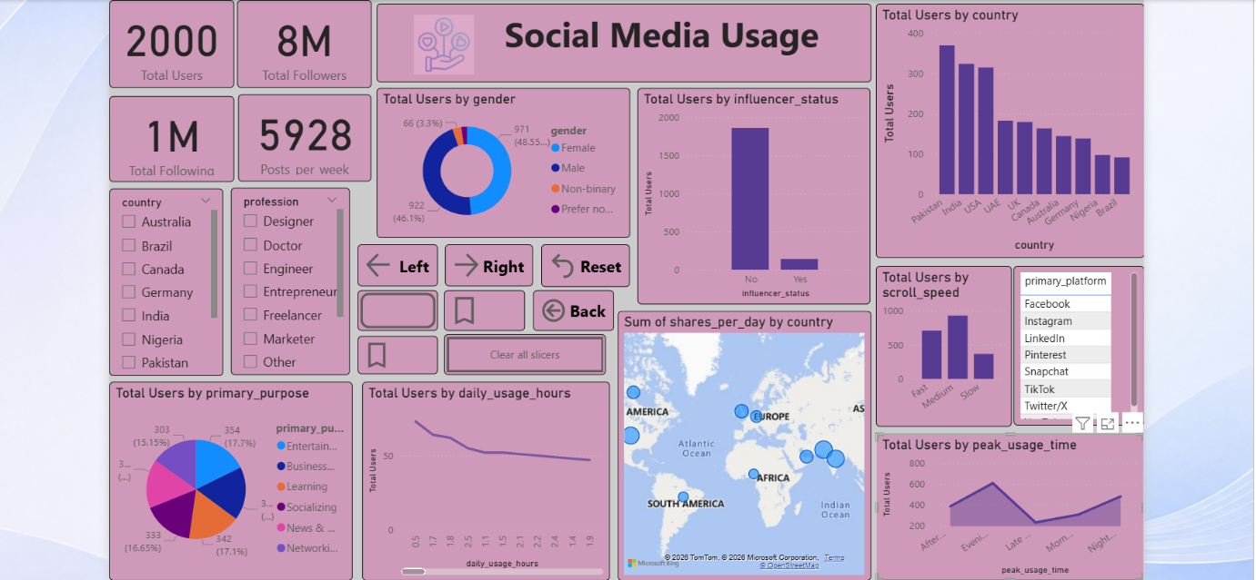

Charts:

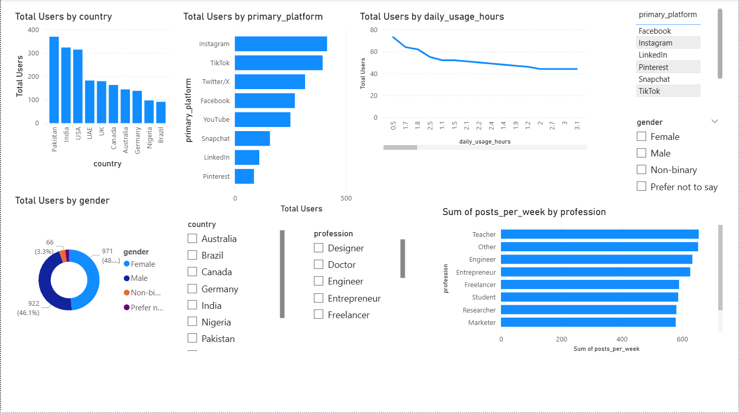

Tooltips:

